Enterprise Wired and wirelesss Network design

Project Report

Akhil Malik

000457595

Table Of Contents

Introduction 2

Network Design 2

Company Internal Network 2

Company- ISP Connectivity 3

IP Address Planning 3

Networking Technologies Used 4

IP Addressing 4

Redundancy 4

HSRP Configuration 5

1 Gbps Interface Bandwidth 6

Spanning Tree Protocol Configuration 6

Security Best Practices 7

DHCP Service Configuration 8

Infrastructure Management 10

VLAN Trunking Protocol (VTP) Configuration 11

Internal Network Connectivity 12

Internal VLAN Connectivity Test 12

Wireless Internal AP to IT-PC-1 12

IT-PC-1 to HR-PC-1 12

HR-PC-1 to Sales-PC-1 13

Sales-PC-1 to Finance-PC-1 13

Finance-PC-1 to MKT-PC-1 13

Guest VLAN can’t ping internal VLANs. 14

DNS Entries 16

Routing 17

Static Route config 18

# Introduction

The network has been designed for a company having both wired and wireless networks. The company is having below number of employees working in the departments. The network planning has been made based on the staff number mentioned below in each department.

|  |  |
| --- | --- |
| **Department** | **Staff** |
| Wireless Guests | 50 |
| Wireless Internal | 40 |
| Finance | 20 |
| Marketing | 15 |
| Human Resources | 10 |
| Sales | 10 |
| Infrastructure Management | 8 |
| IT | 2 |

# Network Design

The below network has been designed to be Implemented in the company for facilitating both wired and wireless users. As there are less staff in some departments, therefore we have combined two departments on a single switch to reduce over cost on the company.

The network portion with the private IP network is fully company owned network and the public network is provided by the ISP for availing internet services.

## Company Internal Network

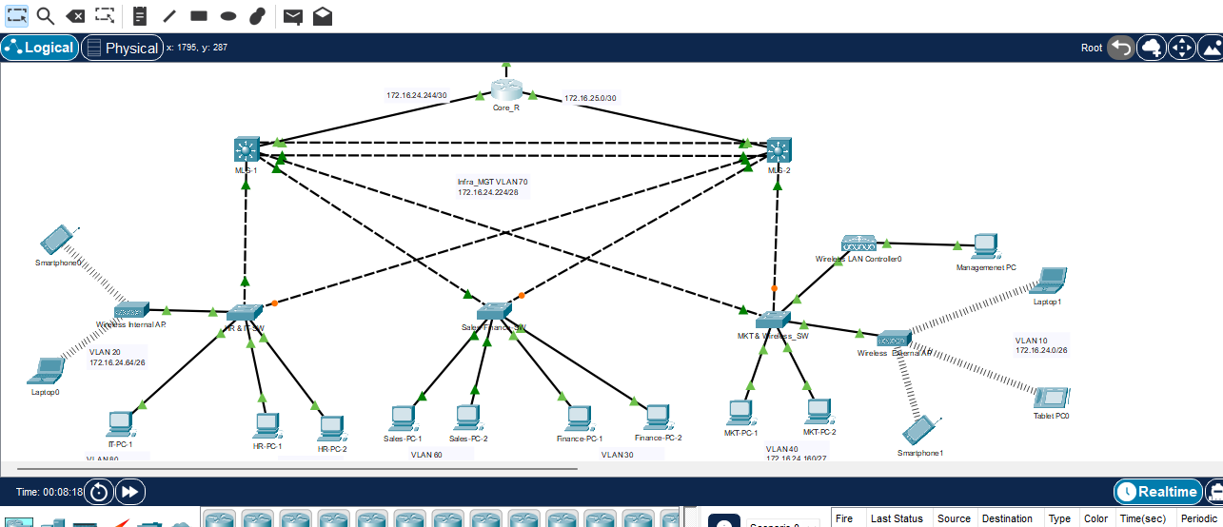Below is the company’s internal network where the end user devices are connected to layer-II switches which are then connected to the multi-layer switches to transit traffic to the ISP via a company core router.

## Company- ISP Connectivity

The below infrastructure has been provided by the ISP and company’s internal network is connected to the public network through a single ISP connection which is provided by the ISP.

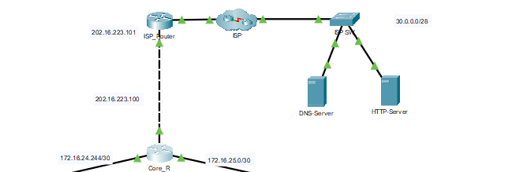

The company router is connected to the ISP router via Public IP address and the public web and DNS servers.

# IP Address Planning

The IP address planning has been done using the IP subnet provided, which has been further subnet using the VLSM mechanism to get the below IP subnets according to the requirement of the network.

|  |  |  |  |  |  |  |  |
| --- | --- | --- | --- | --- | --- | --- | --- |
| **Subnet Name** | **VLAN** | **Needed Size** | **Allocated Size** | **IP Subnet** | **Dec Mask** | **Assignable Range** | **Default Gateway** |
| **Wireless Guests** | **10** | 50 | 62 | 172.16.24.0/26 | 255.255.255.192 | 172.16.24.1 - 172.16.24.62 | 172.16.24.1 |
| **Wireless Internal** | **20** | 40 | 62 | 172.16.24.64/26 | 255.255.255.192 | 172.16.24.65 - 172.16.24.126 | 172.16.24.65 |
| **Finance** | **30** | 20 | 30 | 172.16.24.128/27 | 255.255.255.224 | 172.16.24.129 - 172.16.24.158 | 172.16.24.129 |
| **Marketing** | **40** | 15 | 30 | 172.16.24.160/27 | 255.255.255.224 | 172.16.24.161 - 172.16.24.190 | 172.16.24.161 |
| **Human Resources** | **50** | 10 | 14 | 172.16.24.192/28 | 255.255.255.240 | 172.16.24.193 - 172.16.24.206 | 172.16.24.193 |
| **Sales** | **60** | 10 | 14 | 172.16.24.208/28 | 255.255.255.240 | 172.16.24.209 - 172.16.24.222 | 172.16.24.209 |
| **Infrastructure Management** | **70** | 8 | 14 | 172.16.24.224/28 | 255.255.255.240 | 172.16.24.225 - 172.16.24.238 | 172.16.24.225 |
| **IT** | **80** | 2 | 2 | 172.16.24.240/30 | 255.255.255.252 | 172.16.24.241 - 172.16.24.242 | 172.16.24.241 |
| **MLS-1-Router** | N/A | 2 | 2 | 172.16.24.244/30 | 255.255.255.252 | 172.16.24.245 - 172.16.24.246 | N/A |
| **MLS-2-Router** | N/A | 2 | 2 | 172.16.24.248/30 | 255.255.255.252 | 172.16.24.249- 172.16.24.250 | N/A |

# Networking Technologies Used

Below features have been implemented to make the network a functional design. The network has been carefully designed to provide maximum redundant paths to the traffic and high fault tolerance capabilities during a network issue.

## IP Addressing

The entire private network has been configured used a Class B IP addressing Pool. The main network address used in this case is **172.16.24.0/23.** We have used VLSM for efficient use of IP addresses.

## Redundancy

The network has been designed with high fault tolerance capabilities. We have two redundant paths till the access layer switch. One Access layer switch is connected with two different MLS switches. Ether channel has been configured between the two multi-layer switches to provide fault tolerance and high bandwidth.

Below is the steps to configure an ether channel.

MLS-1#conf t

Enter configuration commands, one per line. End with CNTL/Z.

MLS-1(config)#!

MLS-1(config)#interface Port-channel1

MLS-1(config-if)# switchport mode trunk

MLS-1(config-if)#!

MLS-1(config-if)#!

MLS-1(config-if)#interface GigabitEthernet1/0/2

MLS-1(config-if)# switchport mode trunk

MLS-1(config-if)# channel-group 1 mode desirable

MLS-1(config-if)#!

MLS-1(config-if)#interface GigabitEthernet1/0/3

MLS-1(config-if)# switchport mode trunk

MLS-1(config-if)# channel-group 1 mode desirable

MLS-1(config-if)#!

**Ether channel status**

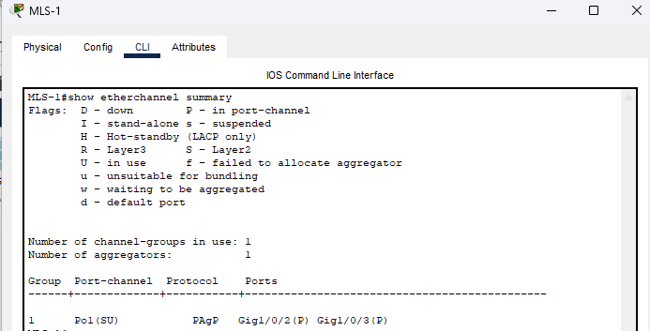

### HSRP Configuration

Apart from this we have also configured HSRP protocol on the MLS-1 and MLS-2 to provide uninterrupted services during a hardware fault with MLS-1. The configuration has been made in a way that services will remain available all the time.

Below is the HSRP configuration done for this purpose.

MLS-1#conf t

Enter configuration commands, one per line. End with CNTL/Z.

MLS-1(config)#!

MLS-1(config)#interface Vlan10

MLS-1(config-if)# ip address 172.16.24.2 255.255.255.192

MLS-1(config-if)# ip access-group WLAN_EXT_BLK in

MLS-1(config-if)# standby 10 ip 172.16.24.1

MLS-1(config-if)# standby 10 priority 200

MLS-1(config-if)# standby 10 preempt

MLS-1(config-if)#!

MLS-1(config-if)#interface Vlan20

MLS-1(config-if)# ip address 172.16.24.66 255.255.255.192

MLS-1(config-if)# standby 20 ip 172.16.24.65

MLS-1(config-if)# standby 20 priority 200

MLS-1(config-if)# standby 20 preempt

MLS-1(config-if)#!

MLS-1(config-if)#interface Vlan30

MLS-1(config-if)# ip address 172.16.24.130 255.255.255.224

MLS-1(config-if)# standby 30 ip 172.16.24.129

MLS-1(config-if)# standby 30 priority 200

MLS-1(config-if)# standby 30 preempt

MLS-1(config-if)#!

MLS-1(config-if)#interface Vlan40

MLS-1(config-if)# ip address 172.16.24.162 255.255.255.224

MLS-1(config-if)# standby 40 ip 172.16.24.161

MLS-1(config-if)# standby 40 priority 200

MLS-1(config-if)# standby 40 preempt

MLS-1(config-if)#!

MLS-1(config-if)#interface Vlan50

MLS-1(config-if)# ip address 172.16.24.194 255.255.255.240

MLS-1(config-if)# standby 50 ip 172.16.24.193

MLS-1(config-if)# standby 50 priority 200

MLS-1(config-if)# standby 50 preempt

MLS-1(config-if)#!

MLS-1(config-if)#interface Vlan60

MLS-1(config-if)# ip address 172.16.24.210 255.255.255.240

MLS-1(config-if)# standby 60 ip 172.16.24.209

MLS-1(config-if)# standby 60 priority 200

MLS-1(config-if)# standby 60 preempt

MLS-1(config-if)#!

MLS-1(config-if)#interface Vlan70

MLS-1(config-if)# ip address 172.16.24.226 255.255.255.240

MLS-1(config-if)# standby 70 ip 172.16.24.225

MLS-1(config-if)# standby 70 priority 200

MLS-1(config-if)# standby 70 preempt

MLS-1(config-if)#!

MLS-1(config-if)#interface Vlan80

MLS-1(config-if)# ip address 172.16.24.250 255.255.255.248

MLS-1(config-if)# standby 80 ip 172.16.24.249

MLS-1(config-if)# standby 80 priority 200

MLS-1(config-if)# standby 80 preempt

MLS-1(config-if)#!

The status of HSRP protocol and configuration of Active/Standby can be verified as below.

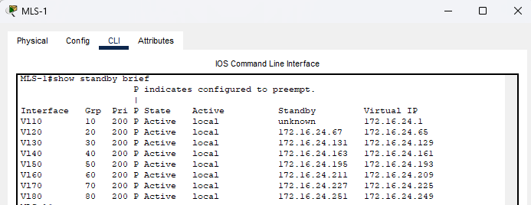

## 1 Gbps Interface Bandwidth

The whole network has been built upon using 1 Gbps interfaces. High capacity 1 Gbps interfaces have been used till the end user devices.

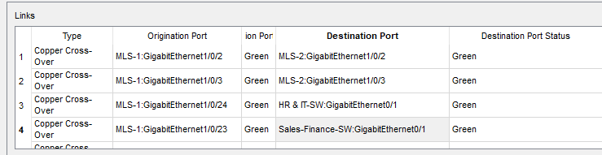

## Spanning Tree Protocol Configuration

The below spanning tree protocol configuration has been done on the multi-layer switch to behave as a primary switch which is carrying all VLAN traffic through it and incase of MLS-1 goes down, MLS-2 will carry the traffic.

MLS-1#conf t

Enter configuration commands, one per line. End with CNTL/Z.

MLS-1(config)#!

MLS-1(config)#spanning-tree mode pvst

MLS-1(config)#spanning-tree vlan 10-80 root primary

MLS-1(config)#end

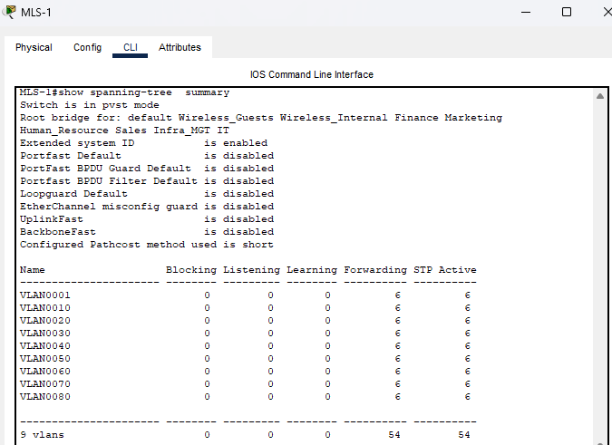

## Security Best Practices

All security best practices have been configured on the switches, routers and servers. All unused services of the servers have been turned off and all console, vty and telnet access of the routers and switches have been configured with password for security assurance.

MKT-Wireless_SW#en

MKT-Wireless_SW#conf t

MKT-Wireless_SW(config)#no ip domain-lookup

MKT-Wireless_SW(config)#enable secret class

MKT-Wireless_SW(config)#banner motd $Unauthorized Access is Prohibited!$

MKT-Wireless_SW(config)#line con 0

MKT-Wireless_SW(config-line)#password cisco

MKT-Wireless_SW(config-line)#login

MKT-Wireless_SW(config-line)#line vty 0 15

MKT-Wireless_SW(config-line)#password cisco

MKT-Wireless_SW(config-line)#login

MKT-Wireless_SW(config-line)#service password-encryption

MKT-Wireless_SW(config)#end

MKT-Wireless_SW#wr

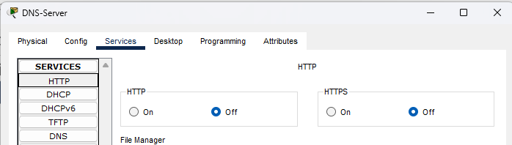

The HTTP/HTTPS service on the DNS server has been blocked. Similarly, DNS services have been blocked on the HTTP Server.

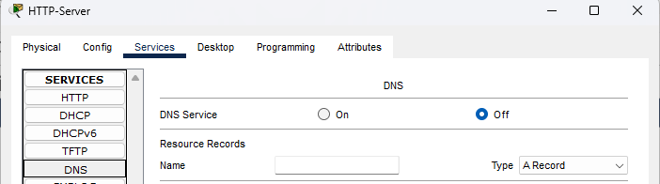

## DHCP Service Configuration

The multi-layer switches have been configured with dynamic IP address assignment while the IP addresses statically assigned have been excluded from the dynamic IP address settings.

MLS-1#conf t

Enter configuration commands, one per line. End with CNTL/Z.

MLS-1(config)#!

MLS-1(config)#ip dhcp pool VLAN10

MLS-1(dhcp-config)# network 172.16.24.0 255.255.255.192

MLS-1(dhcp-config)# default-router 172.16.24.1

MLS-1(dhcp-config)# dns-server 30.0.0.2

MLS-1(dhcp-config)#ip dhcp pool VLAN20

MLS-1(dhcp-config)# network 172.16.24.64 255.255.255.192

MLS-1(dhcp-config)# default-router 172.16.24.65

MLS-1(dhcp-config)# dns-server 30.0.0.2

MLS-1(dhcp-config)#ip dhcp pool VLAN30

MLS-1(dhcp-config)# network 172.16.24.128 255.255.255.224

MLS-1(dhcp-config)# default-router 172.16.24.129

MLS-1(dhcp-config)# dns-server 30.0.0.2

MLS-1(dhcp-config)#ip dhcp pool VLAN40

MLS-1(dhcp-config)# network 172.16.24.160 255.255.255.224

MLS-1(dhcp-config)# default-router 172.16.24.161

MLS-1(dhcp-config)# dns-server 30.0.0.2

MLS-1(dhcp-config)#ip dhcp pool VLAN50

MLS-1(dhcp-config)# network 172.16.24.192 255.255.255.240

MLS-1(dhcp-config)# default-router 172.16.24.193

MLS-1(dhcp-config)# dns-server 30.0.0.2

MLS-1(dhcp-config)#ip dhcp pool VLAN60

MLS-1(dhcp-config)# network 172.16.24.208 255.255.255.240

MLS-1(dhcp-config)# default-router 172.16.24.209

MLS-1(dhcp-config)# dns-server 30.0.0.2

MLS-1(dhcp-config)#ip dhcp pool VLAN70

MLS-1(dhcp-config)# network 172.16.24.224 255.255.255.240

MLS-1(dhcp-config)# default-router 172.16.24.225

MLS-1(dhcp-config)# dns-server 30.0.0.2

MLS-1(dhcp-config)#ip dhcp pool VLAN80

MLS-1(dhcp-config)# network 172.16.24.248 255.255.255.248

MLS-1(dhcp-config)# default-router 172.16.24.249

MLS-1(dhcp-config)# dns-server 30.0.0.2

MLS-1(dhcp-config)#end

MLS-1#

%SYS-5-C

Below are the range of IP addresses that have been assigned to different devices/interfaces statically.

MLS-1#

MLS-1#conf t

Enter configuration commands, one per line. End with CNTL/Z.

MLS-1(config)#!

MLS-1(config)#ip dhcp excluded-address 172.16.24.1 172.16.24.5

MLS-1(config)#ip dhcp excluded-address 172.16.24.65 172.16.24.70

MLS-1(config)#ip dhcp excluded-address 172.16.24.129 172.16.24.134

MLS-1(config)#ip dhcp excluded-address 172.16.24.161 172.16.24.165

MLS-1(config)#ip dhcp excluded-address 172.16.24.193 172.16.24.198

MLS-1(config)#ip dhcp excluded-address 172.16.24.209 172.16.24.213

MLS-1(config)#ip dhcp excluded-address 172.16.24.241 172.16.24.245

MLS-1(config)#ip dhcp excluded-address 172.16.24.245 172.16.24.250

MLS-1(config)#ip dhcp excluded-address 172.16.25.0 172.16.25.3

MLS-1(config)#ip dhcp excluded-address 172.16.24.251

MLS-1(config)#ip dhcp excluded-address 172.16.24.12

MLS-1(config)#end

MLS-1#

Below IP addresses have been dynamically assigned to different devices now.

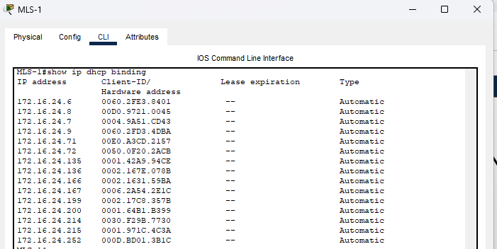

## Infrastructure Management

For the remote management of infrastructure, we have configured management IP addresses on the devices statically and can be managed remotely.

From the IT PC we are accessing the MLS-1 via telnet for remote management as below.

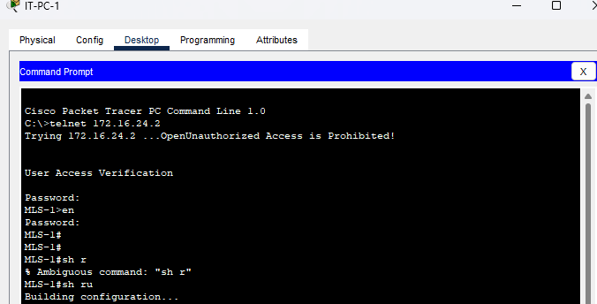

Below is the configuration done on the access layer switch for remote management.

HR-IT-SW#conf t

Enter configuration commands, one per line. End with CNTL/Z.

HR-IT-SW(config)#!

HR-IT-SW(config)#interface Vlan70

HR-IT-SW(config-if)# ip address 172.16.24.236 255.255.255.240

HR-IT-SW(config-if)#!

HR-IT-SW(config-if)#ip default-gateway 172.16.24.225

HR-IT-SW(config)#end

HR-IT-SW#

## VLAN Trunking Protocol (VTP) Configuration

VTP Server has been configured on the MLS-1 and all other switches has been configured as VTP clients. VTP is a protocol to get VLAN configuration populated in the whole switching network without manual VLAN configuration on the switches.

Below is the configuration done on the switches for VTP.

**VTP Server**

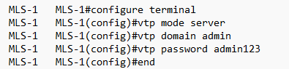

**VTP Client**

# Internal Network Connectivity

We have established internal network connectivity between all departments. The network connectivity can be verified using the connectivity test as below.

## Internal VLAN Connectivity Test

The test between internal VLAN’s have been conducted using the ping tool.

### Wireless Internal AP to IT-PC-1

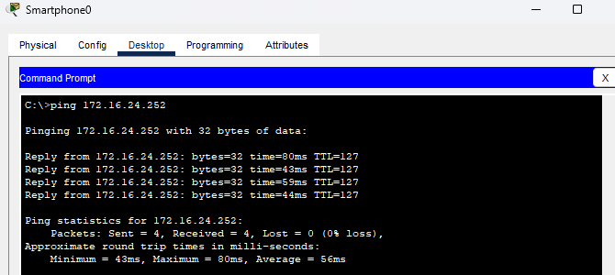

### IT-PC-1 to HR-PC-1

### HR-PC-1 to Sales-PC-1

### Sales-PC-1 to Finance-PC-1

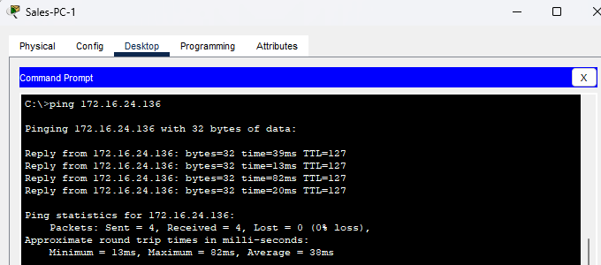

### Finance-PC-1 to MKT-PC-1

### Guest VLAN can’t ping internal VLANs.

We have restricted the ping on Guest VLAN to all internal VLAN’s using an access control list on the multi-layer switch.

Wireless External AP to IT-PC-1

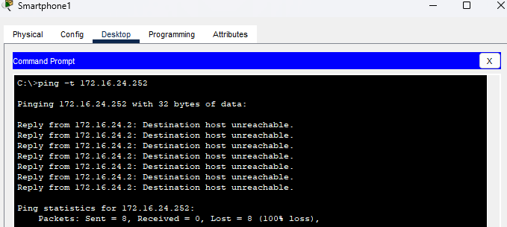

Wireless External AP to HR-PC-1

Wireless External AP to Sales-PC-2

Wireless External AP to Finance-PC-2

Wireless External AP to MKT-PC-1

The Guest Wifi has access to internet only

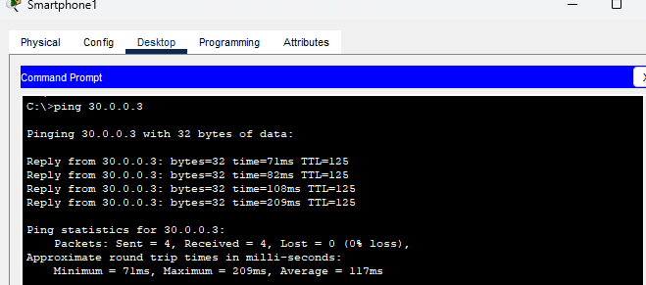

The IP access list has been configured on the MLS-1 & 2 as below.

Interface binding with VLAN interface

## DNS Entries

Below DNS entries have been configured on the DNS Server provided by the ISP.

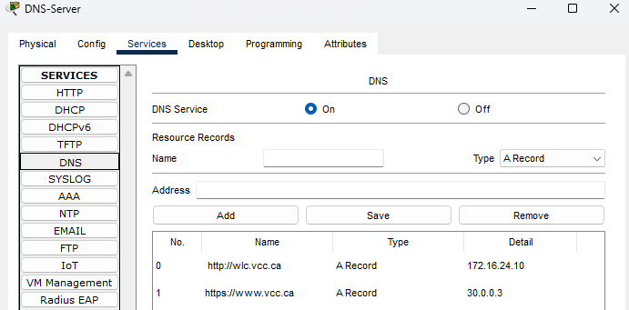

# Routing

Routing has been using OSPF, static and default routing and below is the configuration results.

# Static Route config

Static routing has been done from the ISP end as below.

